Front Wing Aerodynamic Design
Design Decisions & Engineering Justification
A purpose-built multi-element analysis and optimization workflow for a Formula SAE front wing in ground effect
Team / University: _______________________________
Vehicle & competition year: _______________________________
Author(s) & role: _______________________________
Date: _______________________________
Revision: _______________________________
Contents
Right-click here and choose “Update Field” to build the contents.

1 Introduction and the design problem
At FSAE scale the front wing works in a demanding regime: low Reynolds number, low ride height, and strong multi-element interaction. Standard tools cannot model all three fast enough to optimize against, so a purpose-built workflow was used. This document records the design decisions behind the wing and that workflow, the alternatives weighed for each, and how the results were verified.
Why this is a hard problem. Three effects dominate and have to be modeled together, because each changes the others:
- Low Reynolds number. A ~0.35 m main chord at ~15 m/s gives a chord Reynolds number near 3.5×10⁵, and the flap elements run near 1×10⁵. Boundary layers are largely laminar and prone to separation bubbles, so section performance is sensitive and classical high-Reynolds airfoil data does not transfer.
- Strong ground effect. At a ride height of tens of millimetres the wing runs at h/c ≈ 0.05–0.1. The ground accelerates the flow under the wing and raises downforce, but only up to a point: below a critical height the gain saturates and then reverses. Any model that ignores this predicts unbounded downforce as the wing nears the road.
- Multi-element interaction. Downforce at these Reynolds numbers comes from running several elements with slot flow between them. The slots re-energize the boundary layer and let each element carry more load than it could alone — but only if the gap and overlap are right. Single-element tools cannot see this coupling at all.
This ruled out a spreadsheet or a single-element airfoil tool. It needed an analysis method that resolves multi-element flow in ground effect, runs fast enough to optimize against, and is honest about where it stops being trustworthy. Building that method was itself a sequence of engineering decisions, recorded here alongside the decisions about the wing.

2 Design requirements and operating point
Targets only mean something when they trace back to the vehicle. The downforce target sets what the optimizer aims for, the ride-height range sets where the wing must work, and the manufacturing limits constrain the geometry that is allowed to win.
Operating point (as configured in the tool). The design point used throughout this report, and the tool’s documented FSAE-style default, is:
Parameter | Value | Notes
Freestream speed | 15 m/s | Representative cornering speed
Main chord | 350 mm | Sets Reynolds number and reference area
Span | 1400 mm | Rectangular reference planform
Ride height | 30 mm (h/c ≈ 0.086) | Lowest point above the road
Turbulence (Ncrit) | 7 | On-track turbulence; a clean tunnel is 9
Air | ρ = 1.225 kg/m³, ν = 1.5×10⁻⁵ m²/s | Standard sea-level
Main-element Re | ≈ 3.5×10⁵ | 15·0.35/ν
Flap Re | ≈ 1.0–1.2×10⁵ | Per element chord
Dynamic pressure q | ≈ 138 Pa | ½ρV²

These are the analysis inputs, not the vehicle requirements. The vehicle-level targets that justify them — downforce, speed range, ride-height travel, aero balance, packaging, and manufacturing limits — are collected under “To add later if possible” at the end of this document.

3 Methodology: a purpose-built design workflow
The central decision was to build a dedicated analysis and optimization tool rather than assemble the design from off-the-shelf parts. This section explains that choice; Sections 4–7 justify the engineering decisions embedded inside it.

3.1 Choice of analysis method
A purpose-built Hess–Smith panel method was chosen over the available alternatives. The requirement was a solver that resolves multi-element flow in ground effect and is fast enough to sit inside an optimization loop. Three options were considered:
- A general-purpose panel code (AeroSandbox’s inviscid solver). Correct in principle, but it rebuilds a symbolic (CasADi) problem on every call and takes roughly 8–24 s per solve — hundreds of times too slow for an optimizer that needs thousands of evaluations. It also reports lift from circulation (Cl = 2Γ), which Section 4.2 shows is wrong in ground effect.
- Wrapping XFOIL. XFOIL is the standard low-Reynolds airfoil tool, but it is strictly single-element and cannot represent slot flow between elements — the very mechanism the design depends on. It is kept as an optional single-element cross-check, not the core solver.
- A dedicated multi-element panel method (chosen). A Hess–Smith panel method written in NumPy solves the whole stack — all elements coupled, ground included by the method of images — in about 10–100 ms, four to five orders of magnitude faster than the first option, which is what makes global optimization practical.
Higher-fidelity CFD (2D RANS) was never a candidate for the inner loop — minutes per solve rules it out — but it is used as the truth check the fast model is measured against (Section 7).

3.2 Architecture
The tool is a single local application: a pure-NumPy aerodynamics core wrapped by a small web server and a browser-based drawing-office UI, presented as a native desktop window. Isolating all physics in a framework-free core (Figure 1) keeps it testable in its own right — the same core drives the UI, the command-line scripts, and every figure in this document.
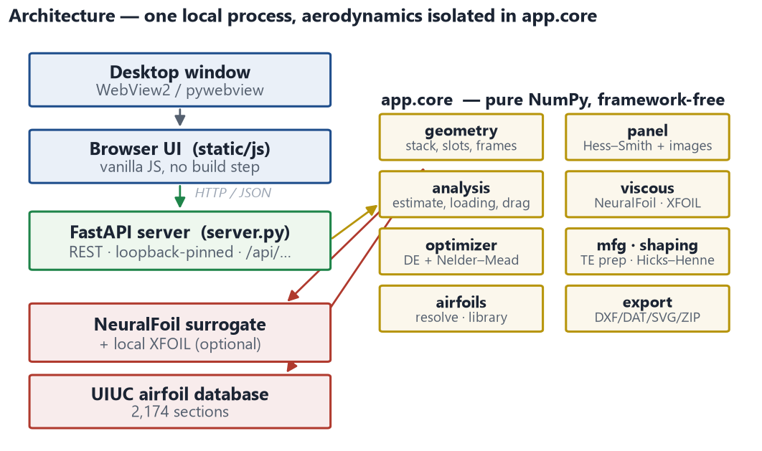
Figure 1. Application architecture. All aerodynamics live in a framework-free NumPy core (right); the server and UI are a thin shell around it.
A design flows through a fixed pipeline (Figure 2): validated inputs build the element stack and solve the slots, the panel method solves the free-air and ground cases, the correction model turns inviscid coefficients into a realistic estimate, and the viscous stage adds the loading budget and drag before forces and warnings are reported.
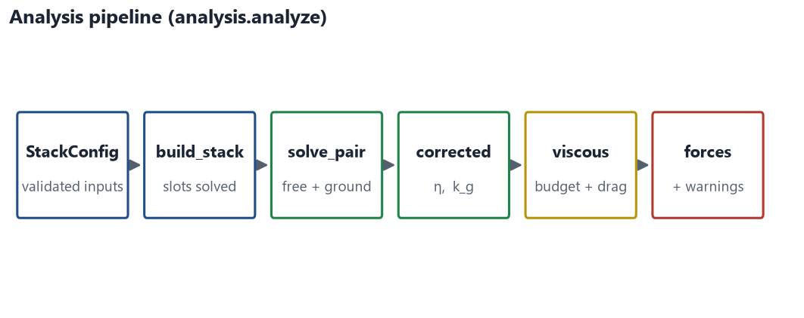
Figure 2. The analysis pipeline, from validated configuration to reported forces and warnings.
One implementation decision runs through the whole tool: every airfoil — a library section, a 4-digit NACA code, an uploaded file, a manufactured (trailing-edge-treated) section, or a shape-refined section — is named by a single resolvable spec string (Figure 3). Because manufacturing and shape modifications are spec layers rather than a post-processing pass, the solver, the viscous polars, the screener, and every exporter all see the as-built shape with no special cases.
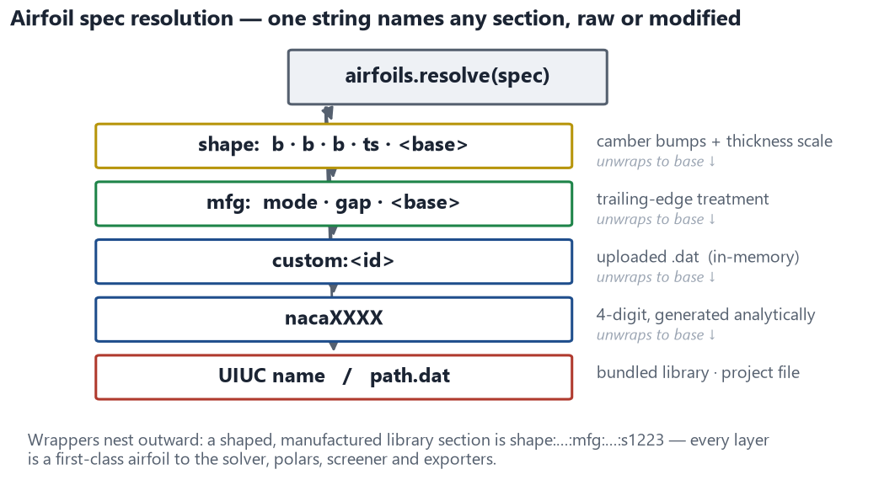
Figure 3. Airfoil spec resolution. One string names any section, raw or modified; wrappers nest outward so every layer is a first-class airfoil to the rest of the tool.

4 Aerodynamic modeling decisions
These are the physics decisions — the ones most likely to be questioned. Each is a deliberate choice with a reason and, where relevant, a validation number.
The solver is inviscid. It resolves the pressure field of attached flow exactly, but it does not model the boundary layer or separation. Viscosity is added afterward — as a bounded ground-effect realization, a viscous efficiency factor, and a per-element stall budget (Sections 4.3–4.5). The predicted numbers are therefore good for ranking designs, not exact. Two things close the gap in practice: the optimizer returns a set of on-target candidates to choose from rather than a single point (Section 5.3), and any candidate can be checked against a 2D RANS solve whose flow-field images show what an attached-flow model cannot — a separated flap, for instance (Section 7).

4.1 Panel method and how forces are computed
Each element contour is discretized into flat panels carrying constant source strengths, plus one vortex per element that sets its circulation (Figure 4). Flow tangency at every panel and one Kutta condition per element (equal-magnitude tangential velocities leaving the trailing edge) close a single dense linear system that couples all elements at once, so slot interaction is captured exactly within the inviscid model.
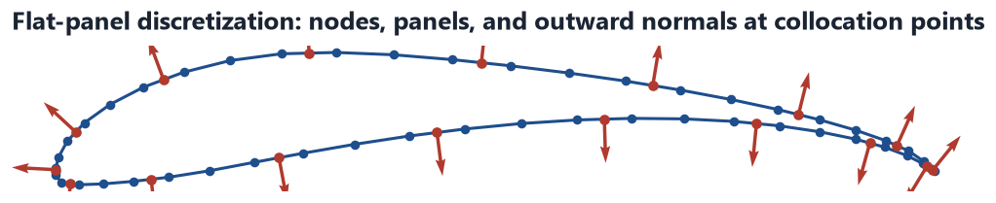
Figure 4. Flat-panel discretization of a real section: nodes, panels, and the outward normals at the collocation points where flow tangency is enforced.
The ground is modeled by the method of images, at no extra cost. A mirror system reflected across the road plane enforces zero flow through the ground automatically: mirroring a source keeps its sign and mirroring a vortex flips it, and both fall out of a single reflection identity, so the image system adds no unknowns to the solve. Because the image plane is only a wall when the freestream is parallel to it, the ground case is always solved with the geometry rotated to the stack angle rather than the flow.
Forces come from integrating surface pressure, not from circulation. Each element’s pressure coefficient Cp = 1 − (Vt/V∞)² is integrated over its panels to get the force directly. This is the decision that makes the ground-effect numbers trustworthy, and it is explained next.
Figure 5 shows the resulting inviscid pressure distribution in free air and in ground effect: the ground deepens the suction on the underside, which is the downforce mechanism.
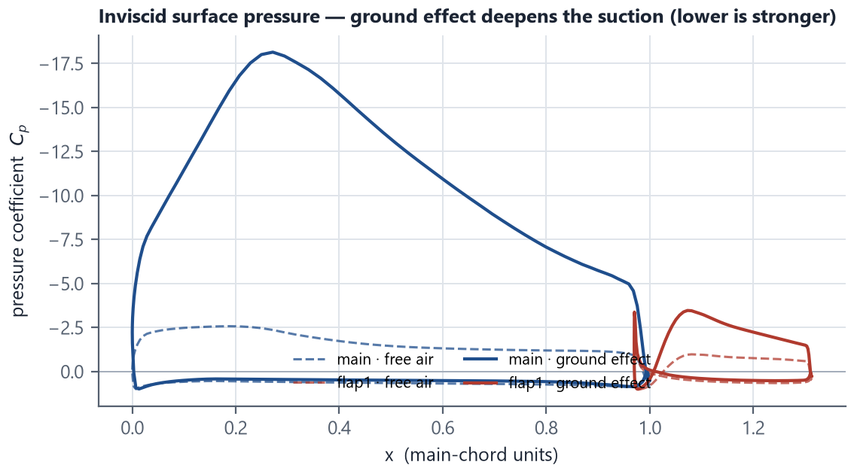
Figure 5. Inviscid surface pressure, free air vs ground effect. Ground effect deepens the suction (lower Cp is stronger) — the physical source of the downforce gain.

4.2 Ground-effect force from pressure integration, not Kutta–Joukowski
In ground effect, lift from circulation (Cl = 2Γ) is simply wrong, and pressure integration is right. During validation the two methods disagreed by a factor of two in ground effect. Integrating the surface pressure of a trusted general-purpose solver’s own velocity field reproduced this tool’s pressure-integrated value, confirming that the circulation shortcut is the one at fault: it ignores the image-induced velocities that the ground adds, so it mis-states the load. Every coefficient this tool reports is pressure-integrated. A practical consequence is that the inviscid ground-effect numbers here are much larger than the older command-line screening printed with the circulation shortcut — the old numbers understated ground effect.

4.3 Turning inviscid coefficients into a realistic estimate
The inviscid solve is exact for its own idealization, but two things stand between it and a number you can trust: viscosity (real boundary layers cap the load and eventually separate) and the fact that inviscid ground effect grows without bound as the wing nears the road, which is unphysical. The correction model addresses both.
The reported estimate is a bounded, ride-height-dependent realization of the inviscid gain. The model is
C_est = η · ( C_free + G_real ) with G_real = cap · tanh( k_g · G_inv / cap ) · tanh( (h/c) / h_choke )
where G_inv = C_ground − C_free is the raw inviscid gain, cap = 3·|C_free| is a saturation ceiling, k_g realizes a fraction of the gain, h_choke = 0.045 chords chokes it off near the road, and η = 0.85 is a viscous efficiency. The alternatives, in the order they were tried and discarded:
- Report raw inviscid only. Diverges toward the ground and misleads.
- A single constant knockdown. Cannot cover both free air (≈ 0.85 realistic) and strong ground effect (≈ 0.3) with one number.
- A ride-height curve k_g alone. Better, but it still does not bound the estimate: the inviscid gain it multiplies grows faster than any reasonable curve vanishes, so C_est kept climbing all the way to the ground — the trend inverted versus published data.
- A bounded saturation model (chosen). The cap limits the realized gain and the choke term takes it to zero at the road. With two constants it reduces to the calibrated behavior where that behavior was right and is bounded everywhere else.
The result (Figure 6) is the physically correct shape: the raw inviscid gain diverges (nearly 19,000% at the lowest height), while the realized estimate peaks near h/c ≈ 0.065 and then falls toward the road — the downforce-reduction-near-the-ground behavior measured in the literature (Zerihan & Zhang). Every constant (k_g, the cap ratio, the choke height, η) is a user-editable knob, and the raw inviscid values are always shown beside the estimate. They are deliberately treated as screening-grade values to be recalibrated against RANS or tunnel data (Section 7).
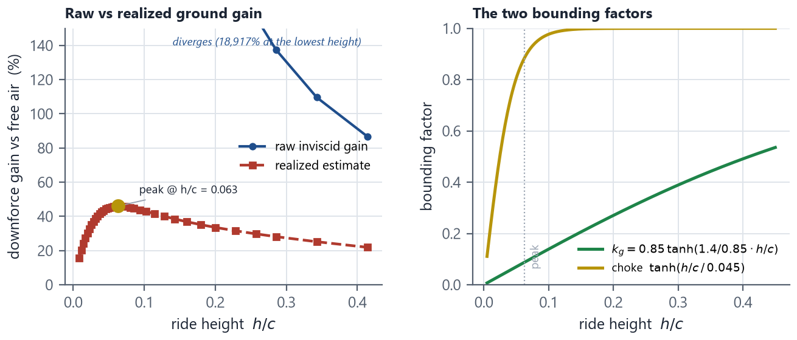
Figure 6. The ground-effect correction. Left: the raw inviscid gain diverges while the bounded estimate peaks (≈ h/c 0.065) then falls. Right: the two mechanisms that bound it — the k_g realization ceiling and the near-ground choke (cap = 3·|C_free|).

4.4 Drag: profile plus induced
Drag is the sum of profile and induced drag; leaving out induced drag produced a physically impossible result. An early profile-only figure gave an implausible L/D ≈ 300, because a loaded finite-span wing pays an induced-drag bill that dwarfs section drag (order 2 N profile against 30–100 N induced at FSAE loads). Profile drag is now looked up per element from the viscous surrogate at the element’s ground-effect operating point, and induced drag is computed in closed form from the same downforce the tool reports:
CDi = CL² / (π·AR·e) · φ with φ = (16h/b)² / (1 + (16h/b)²)
Here e is a span-efficiency input (default 0.9; endplates push it toward 1), and φ is McCormick’s ground-effect factor evaluated at the section mid-height — a wing near the ground sheds a much weaker trailing-vortex system, so its induced drag is reduced (Figure 7). A full lifting-line solve was judged overkill for a screening tool; the classical closed form captures the first-order effect and keeps lift and induced drag consistent by construction.
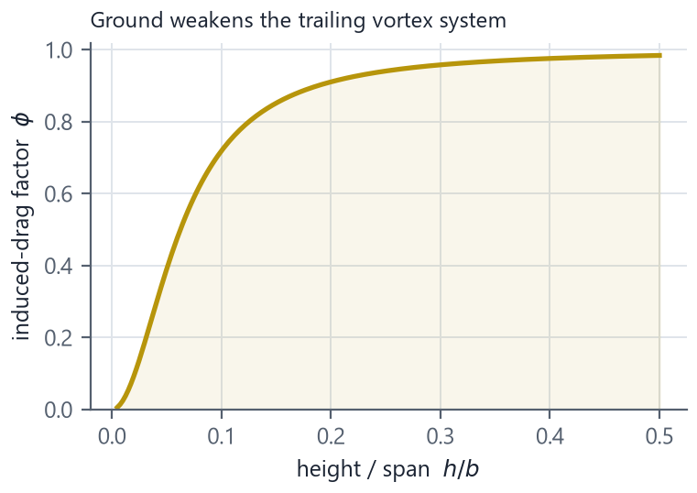
Figure 7. McCormick ground-effect factor φ versus height/span: proximity to the road weakens the trailing vortex system and cuts induced drag.

4.5 Element loading budget
Each element’s load is budgeted against its own stall limit, at its own Reynolds number, on the free-air load. The viscous surrogate gives each element a CL_max at its own Reynolds number; the tool reports each element’s working lift as a fraction of that limit (Figure 8). Budgeting on the free-air load follows classical high-lift practice and is deliberate: inviscid ground-effect element loads grow without bound near the road and made the check meaningless (a plausible design once showed 330% “overload”). A second, ride-height-aware check reports the realized ground operating CL and flags designs that run past about twice the isolated CL_max, beyond which measured multi-element sections rarely stay attached and the estimate turns optimistic.
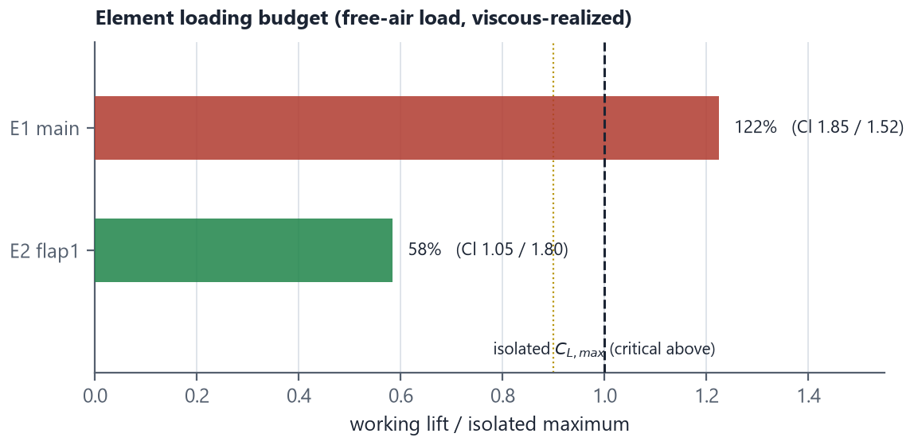
Figure 8. Per-element loading budget: working lift as a fraction of each element’s isolated CL_max, with warning (0.90) and critical (1.10) thresholds.
The surrogate is NeuralFoil — a neural-network model trained on XFOIL that returns a polar in milliseconds, fast enough to call inside the optimizer. For a higher-fidelity check on any element, the “Add XFOIL reference” control overlays a real XFOIL run on that element’s polar, useful both for validating the surrogate and for hand-tuning an element before committing to it.

4.6 Sign and reference conventions
Conventions are fixed once and applied everywhere, so every number in the tool and this report composes consistently:
- Frames. The design frame is upright with lift +y and the main leading edge at the origin; the installed (“as driven”) frame is y-flipped so downforce is +, with the ground at y = 0. Analysis is always done in the installed frame.
- Signs. Positive stack angle and positive (trailing-edge-down) deflection both load the wing. Pitching moment is reported nose-up-positive, with centre of pressure x_cp = −Cm/Cl.
- Reference chords. Stack coefficients are referenced to the main chord (= 1); each element’s own coefficients are referenced to its own chord. RANS coefficients are reported downforce-positive and main-chord-referenced, so they compare directly with the estimate.

5 Optimization and airfoil selection
Turn on manufacturing prep before optimizing. It is off by default (Section 6). With it on, the optimizer works the as-built geometry — the trailing edges the wing will actually have — instead of tuning sharp edges that change once the section is made buildable.

5.1 Optimizer choice and objective
Differential evolution with a Nelder–Mead polish was chosen over gradient-based methods. The objective contains penalty kinks and geometric infeasibility cliffs, so there are no trustworthy gradients through the panel + surrogate chain; a derivative-free global method is the robust choice. Differential evolution is reproducible (fixed seed) and needs no extra dependencies. Search budgets are exposed as Fast / Standard / Thorough (roughly 600 / 1500 / 4000 evaluations).
The objective is a squared relative downforce error plus a weighted drag term plus soft penalties for slot gap, overlap, and element overloading (with hard penalties for element intersection or solver failure). The downforce-error term is weighted so it dominates within a few percent of target, so the optimizer cannot profitably trade downforce away for a small drag saving.
Soft-penalty bands are baseline-relative, so the optimizer can never do worse than the design you started from. A strong overload penalty was needed to stop the search inventing separated-flow “wins”, but a fixed cap created a worse failure: an already-aggressive starting design could not even be matched, so optimizing it returned less downforce than the user began with. Each run now widens its penalty bands once to include the starting design, so the guard means “do no harm” rather than “deny the baseline”; a regression test pins the invariant that optimizing toward a higher target never loses downforce.

5.2 Design variables
The optimizer can move stack angle, per-element deflection, and slot gap and overlap by default, and optionally flap chord ratios, the airfoil of each element, and per-element shape refinement. Slots are parameterized as gap and overlap in percent of chord (Figure 9) — the quantities every high-lift reference and every engineer actually thinks in — rather than raw offsets, and the placement solver hits the requested values essentially exactly.
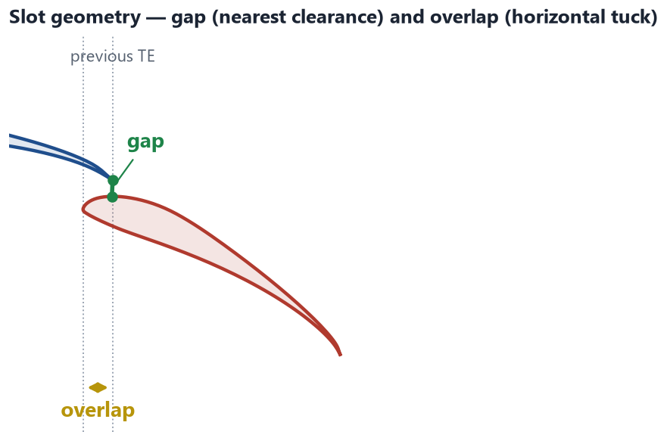
Figure 9. Slot geometry as the optimizer sees it: gap (nearest clearance to the previous trailing edge) and overlap (horizontal tuck), both in percent of chord.
Airfoil choice is a continuous variable over a screened shortlist, not a raw library index. Encoding ~2,200 alphabetically ordered sections as an integer would make neighbouring values unrelated shapes and degenerate the search to random sampling. Instead each element gets a ~16-section shortlist built by the screener at that element’s Reynolds number (best CL_max, best L/D, lowest drag at the working CL), mapped onto one continuous variable ordered by CL_max — so nearby values are similarly aggressive sections and the search stays meaningful. Practical thickness floors keep structurally impractical sections out of the shortlists.
Shape refinement uses Hicks–Henne camber bumps plus a thickness scale. Three camber bumps at 25/55/80% chord (the classical front/mid/aft loading levers) plus one thickness-envelope scale give four smooth degrees of freedom per element (Figure 10). This keeps every shape airfoil-like, so the viscous surrogate’s polars stay meaningful — unlike a free CST re-parameterization, which wanders into shapes the surrogate cannot rate.
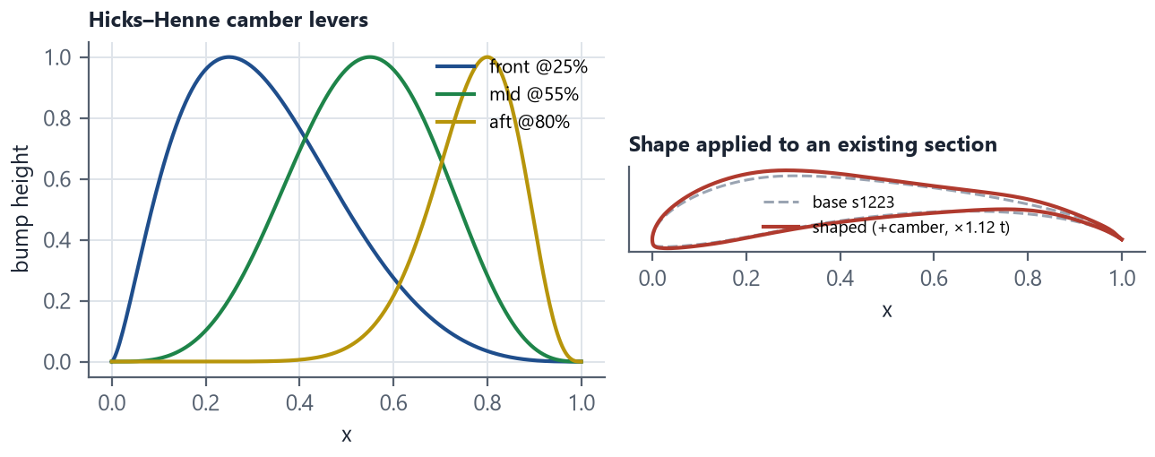
Figure 10. Shape refinement. Left: the three Hicks–Henne camber levers. Right: a real section modified with added camber and a thickness scale, still smooth and airfoil-like.
Shape refinement and airfoil selection are off by default, and for good reason. Both feed the same inviscid estimate, so both can find load the viscous surrogate and RANS will not confirm. Shape refinement is the riskier of the two: it synthesizes camber the attached-flow model rewards without penalty, so a shaped section can “cheat” the engine, and its results diverge from RANS more than a fixed airfoil stack does. Airfoil selection is safer, because it only picks from real, screened sections. Treat any design that used either as a lead to verify against RANS (Section 7), not a finished answer.

5.3 Output: a candidate set, verified at full resolution
The optimizer returns a set of genuinely distinct on-target designs, not a single point. Every feasible evaluation is archived; on finish the tool returns the best design plus up to three alternates chosen farthest-point-first from the on-target, low-penalty pool. This surfaces real trade-offs — for example the same downforce at a tight, drag-efficient slot versus an open, build-tolerant one — instead of jitter around one optimum. It also gives you several honest options to push through RANS rather than a single point estimate. Figure 11 shows a real run converging to target.
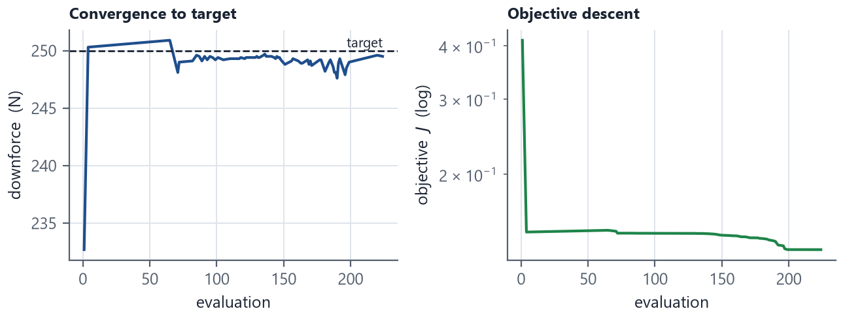
Figure 11. A real optimization run: downforce converging to the target (left) and the objective descending (right).
Two decisions keep the results honest. The search runs at coarsened paneling for speed (60/50/45 panels per side for 2/3/4-element stacks), but the reported winner and every candidate are re-analyzed at full resolution, and “on target” is judged on the full-resolution number. In Thorough mode the early stop is disabled and the final polish runs from several diverse starts at full resolution, which was verified to remove run-to-run scatter in the reported drag.

6 Manufacturing, buildability, and export
Buildability is enforced inside the design loop, not checked after it. A wing the team cannot actually make is not a design. Every trailing edge is opened to a buildable thickness and the as-built contour is what the solver, the polars, and the exporters all see — so with manufacturing prep enabled, the optimizer’s optimum is the buildable optimum. The prep is a toggle and is off by default — turn it on before analyzing or optimizing a design you intend to build.

6.1 Trailing-edge treatment
A knife-edge trailing edge cannot be laid up. Two treatments are offered (Figure 12):
- Thicken (default). Adds thickness symmetrically about the camber line over the aft chord, keeping chord, planform, and camber — so the section keeps its design loading. On the two-element baseline it costs well under 1% downforce at the default 1.2 mm trailing edge. This is the standard aerodynamic preparation, hence the default.
- Truncate. Literally cuts the section back to the thickness target, for when a finished part or mould must be cut. On thin, aft-loaded sections this is expensive (about −17.5% downforce on an S1223 at a 1.5 mm target — the curled tail it removes is where the load lives), and the UI says so.
A V-notch was rejected: it replaces one knife edge with two, adds a stress riser, and has no aerodynamic benefit at these speeds. No separate base-drag model is added, because the viscous surrogate’s shape parameterization already includes trailing-edge thickness — adding a Hoerner-style increment on top would double-count.
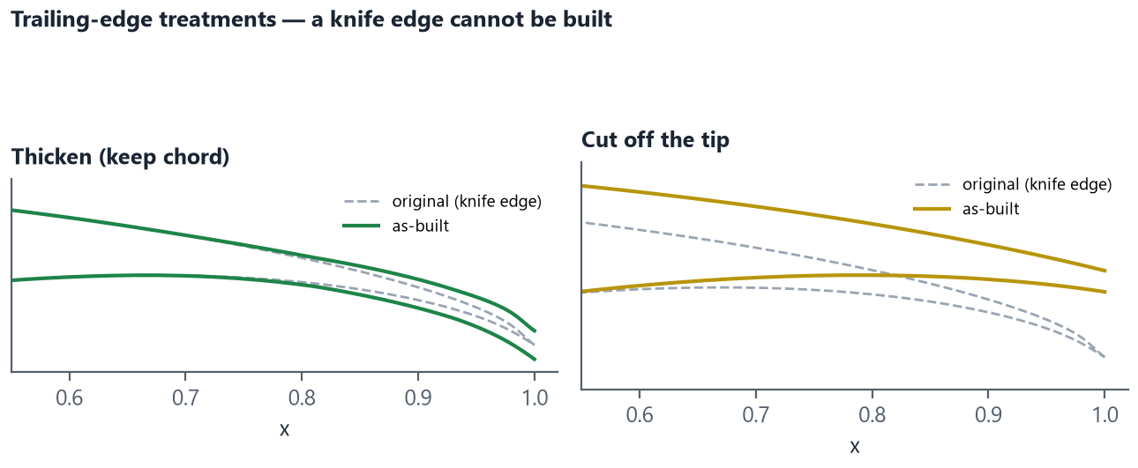
Figure 12. Trailing-edge treatments on a real section: thickening (keeps chord) versus truncation (cuts the tip). A knife edge cannot be built.

6.2 Aft-thickness floor and the “plate” case
Opening the trailing edge is not enough; the whole aft region is floored to at least the trailing-edge thickness. A library-wide scan found that most sections kept a “waist” thinner than the trailing edge they had just been opened to — also unbuildable. Thickening now adds material wherever the aft thickness falls below the gap, and the floor is verified to survive the downstream spline repaneling, not just hold at the polyline nodes (Figure 13, left). A section whose thickest point is barely above the requested trailing edge cannot honor the treatment at all — flooring it would produce a constant-thickness plate with a knife nose — so that case is flagged critically rather than silently reshaped (Figure 13, right).
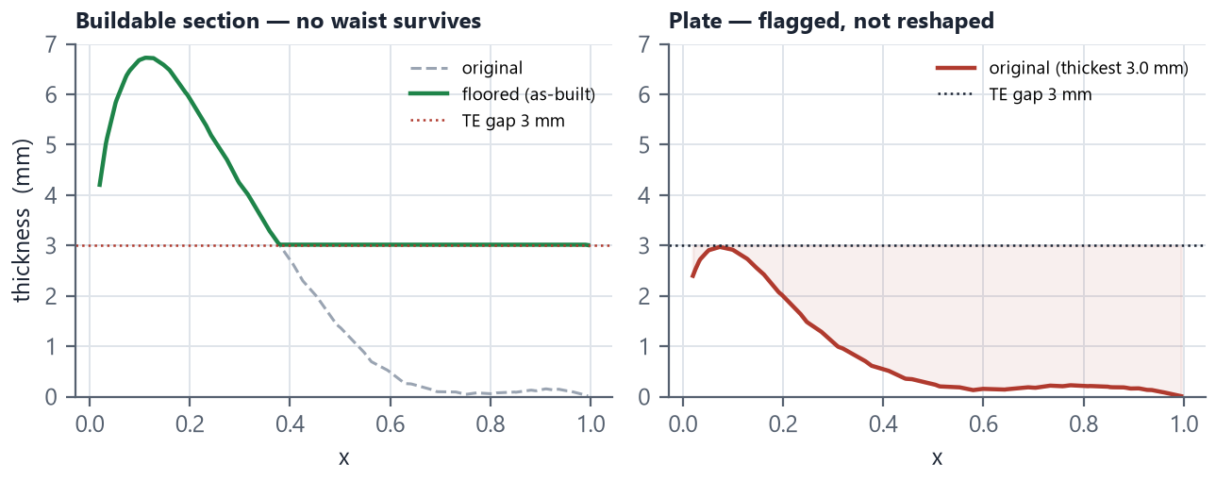
Figure 13. Left: the aft-thickness floor removes a sub-trailing-edge waist on a buildable section. Right: a section too thin to treat is flagged as a plate, not reshaped into something never chosen.
Minimum thickness is a check and a selection filter, never a silent reshape. If a chosen section is too thin, the tool warns and keeps thinner sections out of the optimizer shortlists and the screener — but it does not fatten a section the user selected, which would change the aerodynamics far more than any trailing-edge treatment.

6.3 Export to CAD and CFD
DXF is the primary and most useful export; no STEP. A true-scale DXF (millimetres, one layer per element, optional ground line) drops straight into an Onshape drawing at 1:1 — ready to trace, dimension, or loft — and imports the same way in SolidWorks, Fusion, and NX, all without a heavyweight OpenCascade dependency. Blunt bases export as an open surface spline plus a straight base line so corners stay sharp. The tool also writes point files, Selig contours, a JSON manifest of the as-built geometry, and a complete, ready-to-run OpenFOAM case (Section 7).

7 Verification and validation
A fast screening model is only useful if its errors are known. The workflow is layered: the panel method is checked against exact and higher-fidelity references, and a 2D RANS solve is the truth check the tool is calibrated against.
Neither XFOIL nor OpenFOAM has to be installed — the whole design loop runs without them. Installing Docker is recommended, though: it runs the OpenFOAM case in one click and gives the final confirmation step that turns a screening estimate into a checked result.

7.1 Solver validation
Reference | What it checks | Agreement
Karman–Trefftz exact solution | Inviscid lift, no external tools | within 0.5%
General-purpose solver (pressure-integrated) | Free air and ground effect | ~3%
XFOIL (inviscid) | Single-element sections | consistent
OpenFOAM RANS (Docker vs WSL) | Runner interchangeability | Cl 2.678 vs 2.68

The test suite pins these as closed-form anchors so a future change that breaks the physics fails a test rather than shipping — including an exact induced-drag recomputation that provably rejects a broken formula, and export-content checks that the exported geometry equals the analyzed geometry.

7.2 In-app 2D RANS truth check
The exported OpenFOAM case can be run in one click, and the runner decides for itself when the solve has converged. The case is a steady k-ω SST solve (simpleFoam) on a gmsh mesh sized for y+ ≈ 1, with the road modeled as a no-slip wall moving at the freestream speed — the correct reference frame for a wing over a road. Rather than trust a fixed iteration count or residuals alone (loaded high-lift cases converge in forces long before residuals), the runner watches the lift history and stops the solver when it flattens; runs that hit the iteration cap while still trending are labelled NOT CONVERGED and are not allowed to calibrate anything. Converged runs report the coefficients beside the panel-model estimate and the single k_g value that would make the estimate reproduce the RANS load — closing the calibration loop the correction model was designed around.
The flow-field images are the most useful output for diagnosis: a separated flap or a large wake shows up immediately, and that is exactly the class of disagreement the attached-flow screening model cannot represent on its own.

7.3 Off-design behavior
A wing tuned at one ride height can be wrong across the suspension travel, and the correction model predicts a downforce peak that a single-point analysis never shows. The Maps tab sweeps the design across ride height or speed and plots the result (Figure 14), keeping the single-point optimizer honest while making the trade-off visible: the default template peaks near 20 mm ride height and falls off both sides, the expected ground-effect shape.
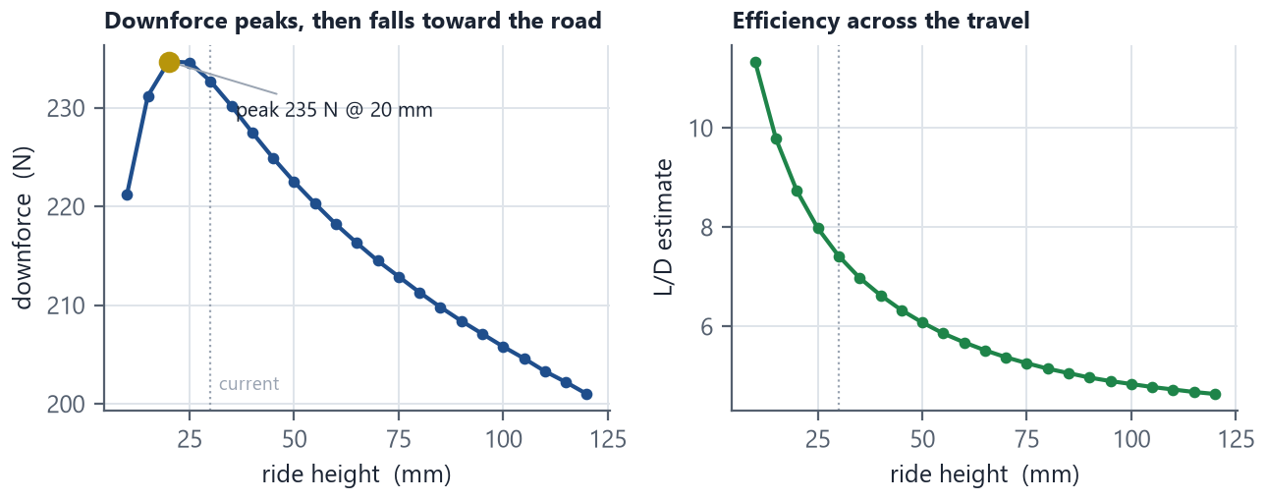
Figure 14. Operating map: downforce peaks then falls toward the road (left) and L/D across the ride-height travel (right), swept from the same model the analysis uses.

8 Limitations and future work
Stating the model’s limits is part of using it well; none of these are hidden from the user in the tool.
- Inviscid core. Downforce comes from an inviscid solve corrected for viscosity and ground effect. The bounds in Sections 4.3–4.5 keep the numbers reasonable, but they are estimates for ranking, not exact loads — which is why RANS is the truth check.
- Screening-grade calibration. The ground-effect and viscous knobs (k_g, cap, η) are physically-shaped starting values, not yet calibrated to this car’s RANS or tunnel data. The RANS verify loop exists to close this, and every knob is editable.
- 2D sections, not the 3D wing. The tool designs the section; tip/endplate vortices, spanwise flow, and interaction with the nose and floor are represented only through the span-efficiency and lift knockdown factors, not resolved.
- Coarsened optimizer search. Searches run at reduced paneling for speed; this is mitigated by full-resolution re-analysis of every reported design, but the search landscape itself is slightly approximate.
Planned tool improvements. Two are worth noting because the current behavior can mislead:
- Default manufacturing prep on. The prep is off by default and the optimizer does not warn when it runs without it, so sharp geometry can be optimized by mistake. Defaulting it on, or prompting before an optimize run, would remove the trap.
- Use the confidence signals already computed. The optimizer computes a NeuralFoil confidence and near-stall / clamped-drag flags on every evaluation but ignores them. Penalizing low-confidence or near-stall designs in the objective — and showing the flags on each candidate card — would curb the shape-refinement over-optimism noted in Section 5.2.

Appendices

Appendix A Key model constants (defaults)
Quantity | Symbol / field | Default
Viscous efficiency | η (viscous_efficiency) | 0.85
Ground-gain cap ratio | gain_cap_ratio | 3.0 · |C_free|
Choke height | h_choke | 0.045 c
k_g small-h slope / ceiling | ground_gain_factor | 1.4 per h/c / 0.85
Span efficiency (induced drag) | e (span_efficiency) | 0.9
Lift knockdown (finite span) | efficiency_3d | 1.0 (presets 0.9)
Ground loading allowance | GROUND_CL_ALLOWANCE | 2.0 × CL_max
Loading warn / critical | LOAD_WARN / LOAD_CRIT | 0.90 / 1.10
Full paneling | n_panels_per_side | 70 / side
Search paneling (2/3/4 el.) | coarse base | 60 / 50 / 45
Default TE thickness | te_gap_mm | 1.2 mm
Reynolds surrogate floor | RE_FLOOR | 1×10⁴
DE search budgets | Fast/Standard/Thorough | ~600 / 1500 / 4000

Appendix B Conventions
- Design frame: upright, lift +y, main leading edge at origin, main chord = 1.
- Installed frame: y-flipped (downforce +), ground at y = 0; all analysis is done here.
- Positive stack angle and positive (TE-down) deflection both load the wing.
- Pitching moment nose-up-positive; x_cp = −Cm/Cl.
- Stack coefficients referenced to main chord; per-element coefficients to their own chord.

Appendix C Selected references
[1] J. L. Hess and A. M. O. Smith, “Calculation of potential flow about arbitrary bodies,” Progress in Aerospace Sciences, vol. 8, 1967.
[2] J. Katz and A. Plotkin, Low-Speed Aerodynamics, 2nd ed., Cambridge University Press, 2001. (Panel methods, method of images, Karman–Trefftz.)
[3] A. M. O. Smith, “High-lift aerodynamics,” Journal of Aircraft, vol. 12, no. 6, 1975. (Multi-element slot flow.)
[4] J. Zerihan and X. Zhang, “Aerodynamics of a single element wing in ground effect,” Journal of Aircraft, vol. 37, no. 6, 2000.
[5] X. Zhang, W. Toet, and J. Zerihan, “Ground effect aerodynamics of race cars,” Applied Mechanics Reviews, vol. 59, 2006.
[6] B. W. McCormick, Aerodynamics, Aeronautics, and Flight Mechanics, 2nd ed., Wiley, 1995. (Ground-effect induced-drag factor.)
[7] M. Drela, “XFOIL: An analysis and design system for low Reynolds number airfoils,” in Low Reynolds Number Aerodynamics, Springer, 1989.
[8] F. R. Menter, “Two-equation eddy-viscosity turbulence models for engineering applications,” AIAA Journal, vol. 32, no. 8, 1994. (k-ω SST.)
[9] C. Geuzaine and J.-F. Remacle, “Gmsh: a 3-D finite element mesh generator,” Int. J. Numer. Methods Eng., vol. 79, 2009.
[10] P. D. Sharpe, AeroSandbox and NeuralFoil (open-source aircraft-design and airfoil-surrogate tools).
[11] OpenFOAM, ESI-OpenCFD, openfoam.com.
[12] M. S. Selig et al., UIUC Airfoil Coordinates Database, University of Illinois at Urbana-Champaign.

To add later if possible
The body above stands on its own as a record of the design and the reasoning behind it. These vehicle-specific items are worth adding once the numbers and hardware are settled:
- Vehicle context and goal. The car and season this wing is for, its role in the aero package (balance, floor, undertray), and the top-level objective it serves.
- Requirements and targets. Target downforce (with the lap-time or grip argument behind it), speed range, static and dynamic ride-height travel, front/rear aero balance, packaging and regulatory envelope, and in-house manufacturing limits.
- The final chosen design. Element count and airfoils, chord ratios, stack angle and deflections, slot gaps and overlaps, and the manufacturing settings — with a drawing or screenshot from the tool.
- Predicted and verified performance. Design-point downforce, L/D, and loading margins against the targets, plus the RANS-verified numbers and any recalibrated k_g / η.
- Test correlation. Wind-tunnel or on-track data (load cells, ride-height sensors, coast-down or aero-balance testing) versus prediction, if available — the strongest evidence there is.
- Team-specific references. Vehicle-dynamics targets, prior years’ aero reports, and test-campaign write-ups.
- Next steps. The team’s prioritized roadmap — for example RANS or tunnel calibration, a 3D check of the installed wing, or multi-point optimization across the ride-height travel.

